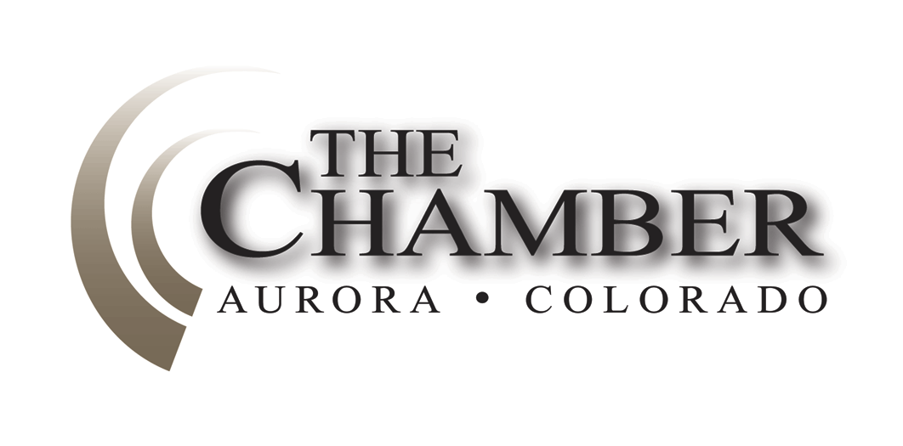Better to remain silent and be thought a fool than to speak out and remove all doubt.''
January 20, 2014
http://www.coloradocapitolwatch.com/bill-tracker-votes/0/391/2014/0/

- Abraham Lincoln
Days Until Sine Die: 107
Days Until Super Bowl: 13
Axiom thanks the many news sources from which we gather relevant stories for our weekly newsletter. In most cases you will be able to read the full text article for each headline below by clicking on the link provided. The purpose of this format is to share newsworthy items while ensuring we adhere to copyright law.
Legislature observes Martin Luther King Day
The legislature will not convene this morning in observance of the Martin Luther King (MLK) holiday. Instead many will attend parades and other festivities in their districts. Meeting for 120 calendar days, it’s rare that the legislature observes a holiday. Typically MLK day and the Good Friday/Passover holiday preceding Easter weekend are the only two days where the General Assembly does not convene. The normal schedule will resume tomorrow.
Newest Member of Colorado Supreme Court Sworn into Office.
Colorado Springs Gazette
William W. Hood III took his oath Monday afternoon at the state judicial center in downtown Denver. Gov. John Hickenlooper appointed the 50-year-old Denver judge to replace retiring Chief Justice Michael Bender in October. It's the governor's second appointment to the state's highest court. The court's new chief justice, Nancy E. Rice, administered the oath of office.
Click here to read more.
Colorado Rep. Sue Schafer Will Not Seek Re-election
Denver Business Journal
State Rep. Sue Schafer, considered one of the most business-friendly Democrats in the Colorado House, announced Monday that she will not run for re-election this fall, citing increasing family responsibilities. Since 2009, she has represented House District 24, which centers on the Wheat Ridge area. Schafer is known for breaking ranks with her party and supporting business groups on a number of issues in recent years.
Click here to read more.
2014 CWCB Instream Flow Workshop
www.cwcb.state.us
The Colorado Water Conservation Board’s (CWCB) annual Instream Flow Workshop will be held on the afternoon of January 29, 2014 at the Hyatt Regency Tech Center in conjunction with the Colorado Water Congress Annual Convention. There is no fee for this workshop, and registration with the Colorado Water Congress is not required.
Each year, the CWCB’s Stream and Lake Protection Section hosts an annual workshop that provides state and federal agencies and other interested persons an opportunity to recommend certain stream reaches or natural lakes for inclusion in the State’s Instream Flow (ISF) Program. The entities that make ISF recommendations will present information regarding the location of new recommendations as well as preliminary data in support of the recommendation. There will be an opportunity for interested stakeholders to provide input and ask questions. This year’s workshop will include: (1) an overview of the ISF Program and the new appropriation process; (2) discussion of pending ISF recommendations from previous years; and (3) discussion of the role the ISF Program can play in meeting the Basin Roundtables' nonconsumptive goals and measurable outcomes.
For a general overview of the new appropriation process, visit: http://cwcb.state.co.us/environment/instream-flow program/Pages/InstreamFlowAppropriations.aspx
11 Wildfire-Related Bills Introduced
The Colorado Springs Gazette
The first wildfire bill of 2014 cleared a committee hearing unanimously Tuesday, as lawmakers began to address a problem that has doubled in scope and damage during the past decade. At least 11 wildfire-related bills have already been introduced this session. The legislation deals with everything from a grant program for fire department safety to command jurisdiction during firefighting efforts.
Click here to read more.
Hick Tops Field in Fundraising, Tancredo Leads Republicans
The Colorado Observer
Contributions from labor unions, the health-care industry and business groups helped push Gov. John Hickenlooper to the top of the fundraising heap in the latest campaign-finance reports filed last week. Hickenlooper collected $422,198 in the fourth quarter of 2013 to fuel his reelection bid. Donors include the AFL-CIO, which has so far given $2,750; the AFL-CIO's building and construction fund with $1,000, and several health-care political-action committees, such as $1,050 from the MedNax Federal PAC.
Click here to read more.

Bill on Public Assistance Cards at Marijuana Stores Dies in Committee
Denver Post
A bill that would have blocked the use of public-assistance cards at ATMs in Colorado marijuana shops died in a state Senate committee Wednesday. Sen. Vicki Marble, R-Fort Collins, proposed the bill, saying it was needed to bring Colorado in line with federal law at places where government-issued Electronic Benefit Transfer cards can't be used. Marble said she worried that without the bill the federal government might view the possible use of the cards at marijuana stores as a reason to raid the businesses. Earlier this week, Marble defended her bill against the allegation that it was prompted by a fake news report claiming that marijuana stores were accepting food stamps. Marble said she drafted the bill before the spoof came out.
Click here to read more.
Affordable Housing Development Planned at Union Station
Denver Business Journal
Atlanta developer Integral Group LLC has plans to build a 108-unit affordable-housing rental development near Denver Union Station. The affordable housing will be located, amid a number of much costlier apartments and some of the most expensive office space in Colorado.
Click here to read more.
CDOT Approves $55 Million Westbound Expansion of I-70 at Twin Tunnels
Denver Post
The widening of westbound I-70 at the Twin Tunnels in Idaho Springs is part of a $55 million package of improvements approved last week designed to speed up the heavy traffic that clogs the highway on weekends. Work on the westbound expansion is scheduled to begin this spring and should be finished by year’s end.
Click here to read more.

No IMPACT 64 Statewide Transportation Sales Tax Measure on 2014 Ballot
Boulder Daily Camera
A potential statewide transportation sales tax measure (MPACT 64), that could have provided critical funding to help spur development of Northwest Rail and arterial bus rapid transit in Boulder and Broomfield counties, will not be pursued at the ballot this November. Polling conducted in 2013 to test the measure’s viability showed that voters throughout the state have no appetite for additional taxes. The decision to abandon efforts to put the measure before the electorate this year was made the second week of January.
Click here to read more.
Move Colorado U.S. Attorney General’s Office Recoups Millions
Denver Post
For every dollar spent prosecuting million-dollar swindlers and drug kingpins, the U.S. Attorney's office in Colorado draws back $6 for victims and federal coffers, officials say.
The work of federal prosecutors in Colorado helped generate more than $100 million in court fees and fines, restitution and asset forfeitures in fiscal year 2013. By comparison, the office has an annual budget of $15.4 million.

The calculation doesn't take into account other judicial costs, including payrolls for the FBI or Bureau of Alcohol, Tobacco, Firearms and Explosives; court expenses, including building costs or judge's salaries; public-defender fees and payroll; or prison costs.
The Colorado staff recouped $9 million while pursuing civil and criminal cases, most of it through criminal actions, according to Jeff Dorschner, spokesman for the U.S. Attorney.
The Colorado office also recovered more than $2 million in civil litigation cases by collecting fines and fees for fraud and violations of health, civil rights and environmental laws. The office collects federal debts including those to the Internal Revenue Service and the Department of Education. Nationwide, U.S. Attorney offices raked in $8.1 billion in civil and criminal payments.
Click here to read more.
Colorado Names Marijuana Enforcement Chief
Denver Business Journal
Colorado officials have tabbed Lewis Koski to head the Colorado Department of Revenue's Marijuana Enforcement Division (MED). Koski previously was chief of investigations for the MED, overseeing licensing, background investigations and field enforcement for marijuana businesses.
Click here to read more.

Statewide Preschool through 12th-grade Student Enrollment Grows for 24th Straight Year
Colorado Department of Education
The Colorado Department of Education announced last week that the statewide preschool through 12th-grade pupil count for the 2013-2014 school year increased by 13,438 over the previous year, bringing the total to 876,999 public school students. This number represents the total number of students served. The change represents an increase of 1.6 percent, slightly higher than the growth rate in the 2012-2013 school year, which was 1.1 percent. In 2008-2009, enrollment surged 2 percent, the largest increase in the past 10 years.
The largest 15 districts and their current student enrollments are: Denver Public Schools (86,043 students), Jeffco Public Schools (85,983), Douglas County Schools (66,230), Cherry Creek Schools (54,226), Adams 12 Five Star Schools (42,230), Aurora Public Schools (40,877), Boulder Valley School District (30,546), St. Vrain Valley School District (30,195), Poudre School District (28,439), Colorado Springs School District 11 (28,404), Academy School District 20 (24,481), Mesa County Valley School District 51 (21,894), Greeley-Evans School District 6 (20,450), Falcon 49 (18,880), and Pueblo City 60 (17,990). These 15 school districts, with a total enrollment of 596,868, represent 68 percent of the total statewide enrollment.
On the other end of the size spectrum, 136 of Colorado’s 185 local education agencies (excluding detention centers) have an enrollment of fewer than 2,000 students. These 136 agencies currently enroll 7.9 percent of the total number of students in the state. Of these, 112 enroll fewer than 1,000 students. These 112 local education agencies enroll 4.2 percent of the total number of students in the state.
The 2013-2014 enrollment totals include 16,215 students registered to online educational programs. This is 1.8 percent of all students. The current online enrollment reflects a 2.5 percent decrease from 2012-2013, when there were 16,638 students in online programs.
To access to the complete 2013-2014 school year student count information, click “2013 Pupil Membership” on http://www.cde.state.co.us/cdereval/pupilcurrent.

The Calculator
House Bills Introduced: 162
Senate Bills Introduced: 94
Number of Bills PI’d: 4

