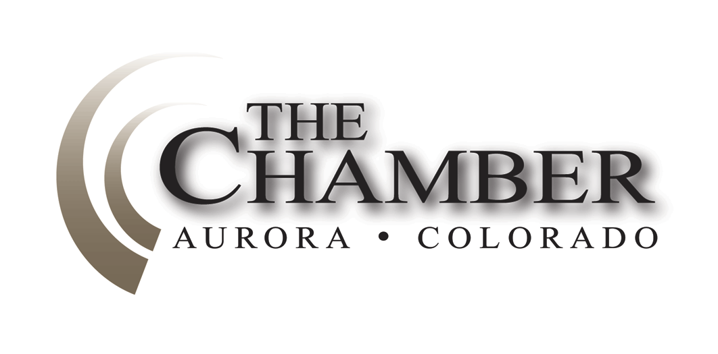“We in America do not have government by the majority.
February 3, 2014
http://www.coloradocapitolwatch.com/bill-tracker-votes/0/391/2014/0/
We have government by the majority who participate.”
– Thomas Jefferson
Days Until Sine Die: 93
Axiom and the Aurora Chamber thanks the many news sources from which we gather relevant stories for our weekly newsletter. In most cases you will be able to read the full text article for each headline below by clicking on the link provided. The purpose of this format is to share newsworthy items while ensuring we adhere to copyright law.
Bill Tracking Keeps Aurora Chamber Members on Top of Key Issues at the State Legislature
Once again, The Aurora Chamber is working with Axiom to track the bills we, through our Board and our Public Issues Committee feel can have the most impact on you. If you would like to see what we are tracking, including the bill number, sponsors and a summary plus a link to the full bill, please go to our Capitol Watch tracking URL: http://www.coloradocapitolwatch.com/bill-tracker-votes/0/391/2014/0/
You can open this URL at any time, and, if you feel so inclined can let us know through out committees, just what you think as well.
We would strongly urge you to bookmark this site and check it often throughout the legislative session.
2016 Republican Convention Could be as Early as June
Denver Post
The Republican National Committee approved rules recently that will allow a yet-to-be-chosen city to host the presidential nominating convention as early as June, rather than the traditional Labor Day weekend. During the RNC’s winter gathering here in Denver, party officials decided to shirt the 2016 RNC to earlier in the summer to allow the presidential candidate to access general election funds earlier in the political cycle. Click here to read more.
Bill on 4-year Degrees at Colorado Community Colleges has Support
Denver Post
The Senate Education Committee passed a bill last week to allow community colleges to grant a limited number of four-year degrees. A similar bill was proposed last year and died in the House. Several of the four-year schools which lobbied against the bill last year are now supporting it, and others have gone neutral. Under the bill, community colleges would offer bachelor of applied science degrees, rather than bachelor of arts or science degrees. The bachelor of applied science or B.A.S., is also a four-year degree, but one tailored more toward specific technical and career paths. Part of the bill says the Colorado Commission on Higher Education will approve the majors proposed by two-year schools as well as notify any four-year schools in their area of the community college’s intent to offer a B.A.S. Click here to read more.
House GOP Wants Compromise on Renewable Energy Bill
Denver Post
House Republicans last week presented two separate compromises on a controversial renewable energy measure, to which Democrat Speaker of the House Mark Ferrandino responded basically, “Been there, tried that.” Ferrandino, sponsor of last year’s Senate Bill 252, said the original measure called for rural electric co-ops to supply 25 percent of their electricity by renewable sources by 2020, but that number was reduced to 20 percent.
One bill heard last week would have reduced the standard to 15% (HB 14-1113), the other would have extended the deadline to 2025 (HB 14-1067). Both bills were postponed indefinitely by the House Transportation and Energy Committee. Click here to read more.

Colorado Launches Go Code Colorado to Make Public Data More Accessible
Last week, the State of Colorado launched “Go Code Colorado,” a statewide public apps challenge to bring the government, business and tech communities together to make public data more accessible and grow the Colorado economy. Go Code Colorado is a bipartisan initiative of Colorado’s Secretary of State’s Business Intelligence Center (BIC), the Governor’s Office and the Statewide Internet Portal Authority. Go Code Colorado is the first competition of its kind in the United States that uses public data to build business tools and grow commerce.

Members of Colorado's business community recently submitted five challenges that they would like to see addressed through better access to public data, including issues such as business site location and access to capital. Teams of Colorado app developers, marketers, mentors, partners and entrepreneurs will compete to address these challenges during the Challenge Weekend, which will be held locally in five regions across the state. Two teams of finalists from each region will advance, giving them the opportunity to work with renowned tech and business mentors from Colorado over the next two months to improve and solidify their apps, before competing at a final competition in Denver. Three winners will receive cash awards, in-kind incentives and investor connections.

Go Code Colorado hopes to be an example of collaboration between tech and government communities that can be applied across the U.S. and spur economic growth in Colorado and beyond. Anyone interested in joining the challenge or supporting Go Code Colorado is encouraged to sign up at gocode.colorado.gov.

Bill to Designate the Claret Cup Cactus as the State Cactus Passes Committee
Last week, Representative Carole Murray’s (R-Castle Rock) bill to designate the claret cup cactus as Colorado’s official state cactus passed the House State, Veterans, & Military Affairs Committee. House Bill 1024 was requested by the Girl Scouts of Troop 2518, based out of Douglas County, as a research project to find the cactus that best represents the State of Colorado. House Bill 1024 will move to the Senate if and when it is passed by House of Representatives as a whole; its next vote has not yet been scheduled in the House.

Denver Teachers Challenge SB 10-191 over Forced Placement of Teachers
Denver Post
A class-action lawsuit filed by the Colorado Education Association last Wednesday challenges the state's teacher effectiveness law, citing concerns with a provision that it says has allowed Denver Public Schools to edge out qualified teachers. The lawsuit follows months of wrangling between the school district and the teachers union over the "mutual consent" provision of the 2010 education reform law that implemented a new system for evaluating teachers. Under the law, school districts are not required to "force" place veteran teachers who lose their jobs because of budget cuts, enrollment drops, or the turnaround process at low performing schools. Teachers can only be placed at a school if the principal wants them. If they cannot find a spot in a year, they are placed on unpaid leave. Meanwhile, a coalition of political figures, business leaders and education reformers sharply criticized the lawsuit, claiming that despite its seemingly narrow parameters it could threaten the entire legislation, also known as Senate Bill 191. Click here to read more.
Statement in Response to CEA Lawsuit Against SB 10-191
Colorado Department of Education
The Colorado Department of Education released the following statement last week relating to the lawsuit filed by the Colorado Education Association against the Great Teachers and Leaders Bill:
The Department of Education has been notified that a lawsuit has been filed today by the Colorado Education Association regarding the mutual consent hiring provisions of the Great Teachers and Leaders Bill (S.B. 10-191). We have instructed the Attorney General’s Office to vigorously defend this challenge. While we respect the judicial process now engaged on this matter, the Colorado Department of Education remains committed to implementing the law and school districts will continue their efforts to upgrade their evaluation systems accordingly.
The filing of this lawsuit does not impact the ongoing work of schools and districts to implement the law. We recognize thousands of educators have worked very hard by collaborating and planning in order to make their evaluation systems more useful and meaningful. To that end, the Colorado Department of Education will continue to provide educators with training and support as they implement improved evaluation systems.
It is important to note that the legal process can take years on matters like this. The Department will monitor the lawsuit as it unfolds. There is no change to the law unless a court issues a ruling indicating changes must be made. The bottom line is that as of today, the law is still in effect and CDE will fulfill its obligation to abide by it and respect the earnest work of Colorado educators to improve their professional growth opportunities.
Video about Colorado Justice Center’s Art to Air on Rocky Mountain PBS
Colorado Creative Industries
Colorado Creative Industries announced last week that the video Imagining the Law: The Art of Ralph L. Carr Colorado Judicial Center, produced by Jessica McGaugh, will air on Rocky Mountain PBS on Sun., Feb. 9, 2014 at 1 p.m.
When the Ralph L. Carr Judicial Center began construction in 2012, ten artists were chosen to design site-specific public art for the building. Imagining the Law follows these artists, giving an inside look at the process of fabricating and installing art in public spaces. The Carr center benefited from a state law allocating 1 percent of new construction costs to acquire public art. Pieces ranging from sculpture to art glass adorn the space created by artists Thomas Sayre, Madeline Weiner, Gary Alsum, Ken Bernstein, WRW Studio, Anne Shutan, Amy Baur, Meltdown Glass, Wowhaus and David Griggs.
Colorado's Creative Industries Division, Colorado's state arts agency, is a division of the Office of Economic Development and International Trade. Established to capitalize on the immense potential for our creative sector to enhance economic growth in Colorado, the mission of Colorado Creative Industries is to promote, support and expand the creative industries to drive Colorado's economy, grow jobs and enhance our quality of life. For more information, please visit www.coloradocreativeindustries.org.
Bipartisan Disaster Relief Package Moves Forward
Colorado House Democrats
Four disaster relief and prevention bills passed with bipartisan support in committee last week. Two of the bills dealt specifically with wildfire prevention while the other two emerged from the Flood Disaster Study Committee.
HB14-1009, sponsored by Rep. Tony Exum (D-Colorado Springs), creates a tax credit up to $2,500 for homeowners who take actions around their homes to mitigate the threat of fires. HB14-1006, by Rep. Jonathan Singer (D-Longmont), targets businesses that saw their profits plunge after the September floods and will increase their access to state revenues unanimously. HB14-1010 by Rep. Millie Hamner (D-Dillon) clarifies regulations about who may oversee a prescribed burn, and HB14-1003 by Reps. Lori Saine (R-Firestone) and Dan Nordberg (R-Colorado Springs) exempts out-of-state disaster relief workers from Colorado income taxes.
Online Education Task Force
Senate Majority Office
Legislators from the Colorado Senate and Colorado House of Representatives have come together in a nonpartisan effort to form a taskforce of leaders in online education. The task force will address the unique challenges facing online education. “As an online educator myself, I know how important it is to increase the quality of online programs. These students deserve a community that is current and fosters excellence in their experiences, and this task force will guide The Colorado Legislature’s work on bringing online education into the 21st Century” said Sen. Andy Kerr (D-Lakewood), who created the task force along with Sen. Ellen Roberts (R-Durango), Rep. Dave Young (D-Greeley), and Rep. Jim Wilson (R-Salida).
Technology and demographics have changed dramatically since the legislature last addressed online education policy seven years ago. Due to the high number of at-risk students in online programs statistics show that full-time online students consistently performed below their non-online peers in reading and math assessments and that graduation rates for full-time online schools are significantly lower than the statewide rate.
The task force will provide policy proposals as well as legislative recommendations by March 21, 2014 to the Senate and House Education committees.
The Calculator
House Bills Introduced: 231
Senate Bills Introduced: 140
Number of Bills PI’d: 24

