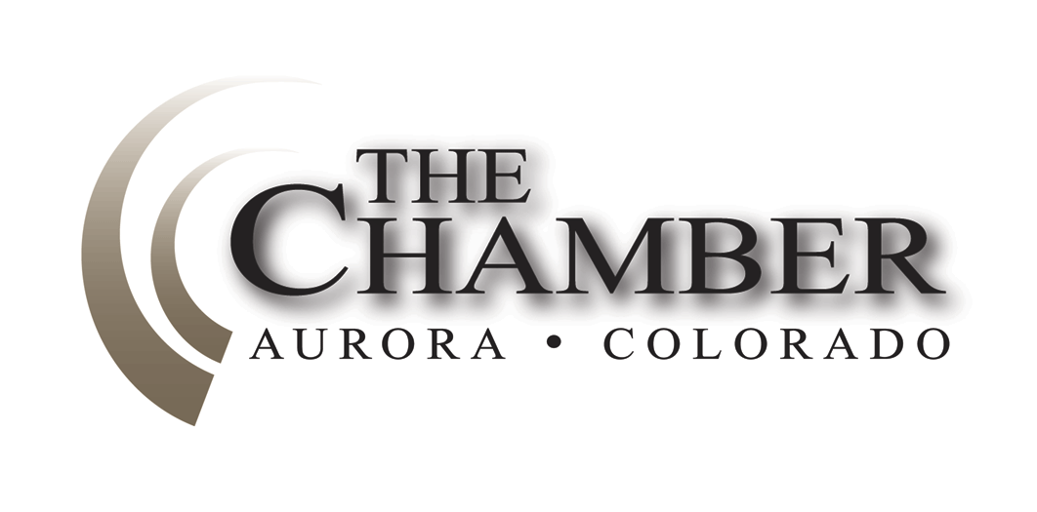
February 11, 2015

http://www.coloradocapitolwatch.com/bill-tracker-votes/0/391/2015/0/
"The most basic question is not what is best, but who shall decide what is best." -Thomas Sowell
Days until Sine Die: 86
Exploring a new track for Colorado workers, from high school to career
Denver Business Journal
While hiring employees with college degrees is an often critical component for many Colorado companies, others are exploring a different way of doing things that involves high school grads going directly into jobs. That's especially important for industries like construction and health care, where employees don't necessarily need to attend traditional four-year universities to obtain degrees and be successful.
Colorado oil, gas task force winnows 57 ideas for easing drilling woes
Denver Post
The governor's oil and gas task force on Monday began to hone in on recommendations for dealing with concerns about drilling in Colorado with most agreement, at least initially, on bolstering state oversight. The group, however, struggled over the key issue of creating a larger role for local government in oversight.
Hickenlooper's task force to take up local control over Colorado oil and gas operations
Denver Business Journal
Gov. John Hickenlooper's oil and gas task force is expected to focus once again on the thorny issue of local governmental control over big energy operations in and near neighborhoods. It's an issue that's been the source of controversy, lawsuits, and court rulings in the last few years, with some communities passing bans on industry operations in their jurisdiction and others cutting deals with operators to demand higher operating standards than the state requires.
Colorado felony DUI bill advances after victims' testimony
Colorado Springs Gazette
Victims of habitual drunken drivers urged Colorado lawmakers Thursday to hand down tougher punishments for offenders. Lawmakers on the House Judiciary Committee responded by unanimously advancing a proposal for stronger penalties for repeat offenders.
With taxpayer refunds in view, Colorado lawmakers debate TABOR
Denver Post
A low-income Colorado family may get an extra $220 tax refund on next year's filing. A middle-class taxpayer may see an average break near $40. A higher earner could save as much as $76. How much each taxpayer could get is a moving target, but the preliminary estimates are energizing the most robust conversation in a decade about the state's unique constitutional cap on taxes, shifting it from the halls of the statehouse to living rooms across Colorado.
Colorado bill on business impact statements returns with legislative backing
Denver Business Journal
A bill that would allow businesses to offer special comments on bills going through the Colorado Legislature is back for a fifth year in a row - but this time it's received the approval of its first committee for the first time in three years. Senate Bill 18 received party-line backing from the Republican-majority Senate State, Veterans and Military Affairs Committee on Wednesday despite the fact that absolutely no one showed up to testify in favor of it. Meanwhile, opposition from liberal and union groups that surfaced at the hearing foreshadowed the tough path the measure from Sen. Tim Neville, R-Littleton, will have in trying to get through the Democrat-dominated House.
Transparency is the key to working through divisive legislative debates
Durango Herald
Moving into February, we've got nearly 340 bills introduced in the House and Senate. That's probably just over half the number that will be filed before the session ends, which gives you a sense of the workload to be accomplished in the 120-day legislative session. Political control of the state Legislature is divided this year, with each party controlling one chamber. The split Legislature will demonstrate differences in basic party agendas and philosophies. Because of these differences, fewer bills under single-party control will make it to the governor's desk for signature or veto.
Committee rejects Colorado's proposed assisted suicide law
The Denver Post
A bill that would have legalized assisted suicide in Colorado failed in a legislative committee on an 8-5 bipartisan vote Friday night. The vote came after 11 hours of testimony from doctors, clergy and people with terminal illnesses and disabilities.
Senate Democrats and Republicans agree on workforce development program
State Senate Democrats
The Colorado economy is outpacing the nation with a four-percent unemployment rate, the lowest since October 2007. Today, Sen. Mary Hodge, D-Brighton, championed bipartisan legislation to keep that momentum going, SB 15-082. It allows a county to establish a workforce development program named "Bright Future Colorado." The program would provide financial assistance to high school graduates who pursue college or training from an accredited school or certified training program.
The legislation, which is co-prime sponsored by Sen. Vicki Marble, R-Fort Collins, was approved on a 34-1 vote.
"This program will help ensure that the needs of Colorado employers are matched with the needs of an educated, well-trained workforce," said Sen. Hodge. "In Colorado we have everything going for us with a growing economy and pioneering spirit. We need to maximize our momentum until all areas of the state are flourishing."
SB 15-082 now moves to the House of Representatives.
Bill tracking system is in place at The Chamber
The 70th Session of the Colorado State Legislature has now begun and The Chamber Government Affair/Education/Energy Committee, with the help of our partners at Axiom Strategies, will be watching them closely to get a sense of their inclinations toward business issues--especially those that could have an impact on the Eastern Metro area.

As of this week, Axiom Strategies Inc. has the Capitol Watch online bill tracking system up and running. Capitol Watch system gives us real-time updates on bills, votes, legislative positions and a vast amount of other information we can use to better assist you in successfully advocating your policy goals.

Over the next few weeks, the legislature will be introducing a significant number of bills. You can use the following URL to see which bills Axiom Strategies Inc. is tracking on your behalf. Feel free to check it frequently, as we will be updating your online profile daily. Here is your tracking URL:
http://www.coloradocapitolwatch.com/bill-tracker-votes/0/391/2015/0/

This link to your bill tracker will be updated daily with newly introduced bills, status and position updates as well as Axiom comments on bills. With session just starting and a large number of bills being introduced, you can expect to see frequent editing over the course of the next few days.
The Calculator
House Bills Introduced: 213
Senate Bills Introduced: 176
Number of Bills PI'd: 46

