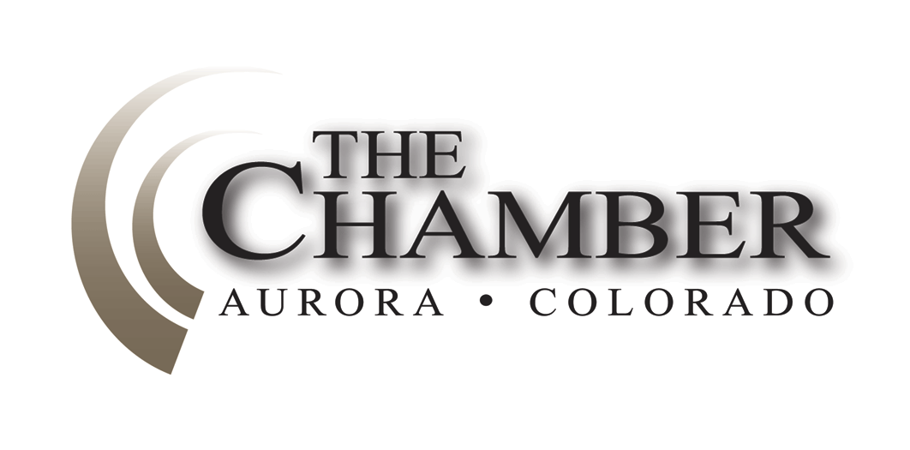“It’s clearly a budget; it’s got a lot of numbers in it” —George W. Bush
March 31, 2014
http://www.coloradocapitolwatch.com/bill-tracker-votes/0/391/2014/0/
Days until Sine Die: 37
Axiom thanks the many news sources from which we gather relevant stories for our weekly newsletter. In most cases you will be able to read the full text article for each headline below by clicking on the link provided. The purpose of this format is to share newsworthy items while ensuring we adhere to copyright law.
Colorado House Gives Initial Approval to Budget Proposal
Denver Post
With the economy recovering and more revenue projected in the state’s general fund this year, Colorado lawmakers in the House last week approved a state budget proposal. The $23 billion proposed fiscal year budget is the most money lawmakers have been able to spend in recent years, and represents a $.1 billion uptick from the current budget. Click here to read more.
The budget, commonly referred to as the “Long bill,” is introduced in the chamber in which the chair of the Joint Budget Committee (JBC) sits. This year that is the House of Representatives. Now that the Long bill has passed through the House, it will be introduced in the Senate. After it is passed by the Senate, the JBC will act as the conference committee to resolve differences between the two chambers. After both chambers adopt the conference committee report, the bill is sent to the Governor who has line item veto power in acting on the bill.
Hickenlooper Vetoes Two Bills
Office of the Governor

After not vetoing a single bill last session, Governor Hickenlooper vetoed two bills last Friday, both sponsored by fellow Democrats. HB 14-1108 would have limited the co-payments required by insurance companies for visits to physical therapists and naturopathic doctors. The governor explained in his veto letter that the “legislation creates a market imbalance which may discourage use of providers outside the scope of this law and fuel anti-competitive practices.”
Hickenlooper also vetoed SB 14-89, concerning payment in lieu of taxes, because the measure limits the state’s authority.
Click here to read more.

Hickenlooper Urges Support for Expanding Broadband to Rural Communities
Office of the Governor

Gov. John Hickenlooper released this statement in advance of several telecommunications bills that were considered by the Colorado General Assembly early last week:
“Simply put, we have a technological divide in Colorado; we cannot afford to have a technological divide in Colorado; and these bills go a long way toward fixing that. Too many Coloradans, especially those in the rural and remote areas of our state, too often don’t have the same access that other parts of the state do to reliable broadband internet service. If passed, the regulatory certainty and sensible incentives in these bills will help ensure we build these necessary bridges to the 21st century so that everyone in our state, regardless of where they live, has a fair chance to grow and prosper, to compete locally and in the global market place. We have no doubt that the entire General Assembly sees the value and need for the opportunities advancements that these bills provide for all Coloradans, and for our continued economic growth. We have complete faith that whatever outstanding issues there may be, will be resolved and these bills will be passed before the end of the 2014 session.”
The governor called for telecommunications reform in his State of the State address at the beginning of the year: “Fourteen years into the 21st century is well past time to reform our telecommunication laws. This session, we ask you to pass legislation that will accomplish this; rural and other unserved parts of our state should have the same broadband internet access as urban areas.”
A diverse group of stakeholders also support the pending changes. Some of these include CLUB 20, the Colorado Association of Wheat Growers and the Colorado Farm Bureau.
Legislative Beer Wars Return – This Time Over Cider
Denver Business Journal

The beer battle of the 2014 Colorado Legislature is underway – but this year it does not involve either craft brewers or grocery stores. Instead, the fight now is over whether hard cider will be regulated as beer for distribution purposes in Colorado. And it pits the country’s two biggest brewers, Anheuser-Busch InBev and MillerCoors, against the state’s growing craft cider industry, as well as smaller liquor stores and the local wine and spirits industry. Click here to read more.

Colorado Creative Industries Annual Summit Speakers
Office of Economic Development & International Trade

Colorado Creative Industries last week announced the speakers for the third annual Colorado Creative Industries Summit, May 1-2, in Salida. The Summit's theme "Creative Convergence" will feature three tracks: Creative Communities, Creative Entrepreneurs and Arts Innovation. The event will explore topics such as legal issues for creatives, engaging local government, collective partnerships and the art of self-promotion.

This year's presenters include renowned singer, songwriter, cellist and pianist Ian Cooke, producer Ian O'Dougherty, animator Adam Singer and a panel of Colorado Artplace America grantees. Consultants from the Colorado Small Business Development Center will be onsite to provide individualized counseling to creative entrepreneurs. Summit attendees include artist-entrepreneurs, owners of creative sector businesses, nonprofit cultural workers and emerging creatives.

Colorado Poetry Out Loud state champion, Alice Kilduff, a senior at Denver School of the Arts, will perform a poetry recitation and the 2014 Governor's Creative Leadership Awards will be announced. Networking activities include a reception hosted by the City of Salida featuring local Jazz Quartet, Equinox and an open house in the Colorado certified Salida Creative District.

Registration for the Summit is $135 through March 28, and then will be $150. Students with ID are $125. The cost includes one breakfast, two lunches, the Governor's Creative Leadership Awards ceremony and all sessions and workshops. Attendees may also choose to attend the Governor's Creative Leadership Awards Luncheon only for $40. Visit www.coloradocreativeindustries.org for registration and a complete description of workshop sessions.

Fracking Initiatives Start to Fracture Colorado
Washington Times

A gusher of proposed ballot initiatives on hydraulic fracturing is poised to flood the November ballot as Colorado digs in for a gritty election battle between the oil and gas industry and environmentalists. Nothing has qualified yet, but it would be no surprise if as many as a half-dozen proposals reach the Nov. 4 ballot, setting up what could become a national proxy war on energy development akin to last year's debate on gun control. Click here to read more.
New Study Shows the Statewide Economic Impact of a Fracking Ban
A study using a calibrated dynamic economic modeling system developed by Regional Economic Models Inc. (REMI) shows that a statewide fracking ban would result in 93,000 fewer jobs, $12 billion in lost gross domestic product (GDP) and an annual reduction of $985 million in tax revenue for local and state governments between 2015 and 2040.
Hydraulic fracturing or “fracking” is a process used to stimulate oil and natural gas wells to produce more energy. Fracking has been used in the United States for more than 60 years and more than 90 percent of all wells today are “fracked.” Although 87 percent of oil and gas activity in Colorado is concentrated in just five counties in Colorado, the employment and tax impacts are much more widespread. The five largest-producing counties represent 35 percent of upstream and midstream employment, the 31 smallest-producing counties represent 29 percent, and the 28 nonproducing counties account for 36 percent.
Likewise, while industry taxes have the greatest impact on local government spending, the industry also pays taxes that flow to the Colorado general fund, which is then spent on everything from education to infrastructure in the state of Colorado. Hence, quelling oil and gas activity would have far-reaching consequences on the economy, including employment, wages, and taxes.
The study, conducted by the Business Research Division (BRD) of the Leeds School of Business at the University of Colorado Boulder on behalf of a partnership between the Common Sense Policy Roundtable (CSPR), the Denver South Economic Development Partnership (Denver South EDP) and the Metro Denver Economic Development Corporation (Metro Denver EDC), provides the first major analysis of 2014 using the new economic tool in Colorado. Click here to view the entire report.
Addressing Dropout Rates through School Innovation
Colorado State Senate Majority Office
Nearly one in five high-risk, alternative school students dropped out of school during the 2012-2013 school year. Last week, Sen. Rachel Zenzinger, D-Arvada, presented a bill before the Senate Education Committee to reduce that alarming dropout rate and provide improved educational opportunities for high-risk students. A high-risk student falls into one or more of these categories: dropout, expelled, adjudicated youth, pregnant/parenting, drug/alcohol abuse, insufficient credits, and more.
The bill, SB 14-167, creates the Opportunity Schools Pilot Initiative, which will provide additional funding for alternative education campuses. Schools that apply to participate in the initiative must describe the model that it will implement to serve high-risk students and must include at least two of the following three elements:
· High-quality college and career-ready instruction that includes strong academic and social support services;
· Programs to build college and career-ready skills and to provide informed counseling to assist students in the transition from high school to postsecondary enrollment; and
· Appropriate support for students in the first year of postsecondary enrollment to ensure postsecondary persistence and success.
For example, schools may adopt a student-centered focus that provides differentiated instruction to its students, a college and career readiness focus, or provide an education that includes wraparound support services, such as substance abuse treatment, child care and behavioral health.
Sen. Zenzinger is also working to boost student success through her School Turnaround Leaders Development Program (SB 14-124) and School Counselor Corps Grant Program (SB 14-150).
Leah Curtsinger to Join CACI
Leah Curtsinger, formerly with the Kirchhof Group, will be the taking on the role of Federal & State Governmental Affairs Representative for the Colorado Association of Commerce & Industry (CACI), where she will be responsible for identifying & engaging CACI's membership on federal policy issues, developing working relationships with the Colorado delegation & their staffs, as well as building coalitions among trade & other business interest groups. She will also play a key role in establishing a Federal Policy Council to develop & align federal policy positions with CACI's mission. At the state level, Leah will support CACI's Senior Vice President Loren Furman & State Government Affairs Representative Carly Dollar on telecom & technology lobbying.
Colorado Senate Committee Stops Expanded Audit of Health Care Exchange
Denver Post
A House bill that saw broad bipartisan support for expanded state oversight of Colorado's health-insurance marketplace while in the House died in a Democrat-controlled Senate committee Wednesday, even as Washington Republicans questioned the security of personal information submitted to the exchange. The Senate Health and Human Services Committee voted 4-3 along party lines to stop the bill, which would have given the state auditor authority for an expanded performance audit of Connect for Health Colorado. Click here to read more.
EPA Seeks Additional Power over Streams and Wetlands
Thousands of miles of Colorado waterways would gain stricter federal oversight under a new approach the Obama administration unveiled last week. The proposed changes come from the Environmental Protection Agency (EPA) and U.S. Army Corps of Engineers. The stated goal is to prevent further fouling, filling-in and dredging of streams, tributaries and wetlands by requiring polluters to obtain permits. However, new definitions within the regulations threaten to potentially affect even the smallest trickle or puddle of water, driving costly permits and significant delays for developers.
The regulations also result in adding a layer of federal oversight and permitting that may infringe on state and local control. Governor Hickenlooper, along with Governor Sandoval of Nevada, sent a letter to the EPA and the Corps of Engineers on behalf of the Western Governors’ Association requesting that these organizations engage states as authentic partners in the management of waters, prior to taking further action on this issue.
Gov. Hickenlooper appoints District Court Judge
Office of the Governor
Last Wednesday Gov. John Hickenlooper appointed Karen L. Brody as a district court judge for the 2nd Judicial District (City and County of Denver). She will fill a vacancy due to the retirement of the Honorable Norman D. Haglund. Ms. Brody is currently a member and owner at Lowe, Fell & Skogg, LLC. Her practice consists of general commercial litigation with a subspecialty in the areas of real estate and eminent domain law. Before working at her current firm, Ms. Brody was a litigation associate at Otten, Johnson, Robinson, Neff & Ragonetti, P.C. She earned her undergraduate degree from the University of Denver in 1982, her Master of Arts from Tufts University in 1983, and her Juris Doctor from the University of Denver College of Law in 1996. The appointment is effective April 18, 2014.
Abel Tapia to Run for Colorado's 3rd Congressional District
Denver Post
A former state legislator from Pueblo has announced he will run for the 3rd Congressional District seat now held by Republican Scott Tipton of Cortez. Abel Tapia, who served in the state House and Senate and recently retired as director of the Colorado Lottery, announced his candidacy last Monday. Tapia told the Sentinel he was urged to run after Pueblo County Commissioner Liane "Buffie" McFadyen dropped out, leaving the Democrats without a strong candidate. Click here to read more.
Shotgun Willie's Boss to Keep His Word, Run for Colorado Governor
KDVR
Mike Dunafon made a promise -- that he'd run for governor if he could get 60,000 “likes” on his Facebook page before his 60th birthday in April. Now he'll have to keep it. Dunafon, the libertarian mayor of Glendale whose fiancée owns Shotgun Willie’s, announced last week that he’s going to run for governor this November as an independent candidate. He said he is working on filling out forms and making plans to get the 1,000 petition signatures necessary to get his name on the ballot. Click here to read more.
The Calculator
House Bills Introduced: 348 - Senate Bills Introduced: 171 - Number of Bills PI’d: 112

