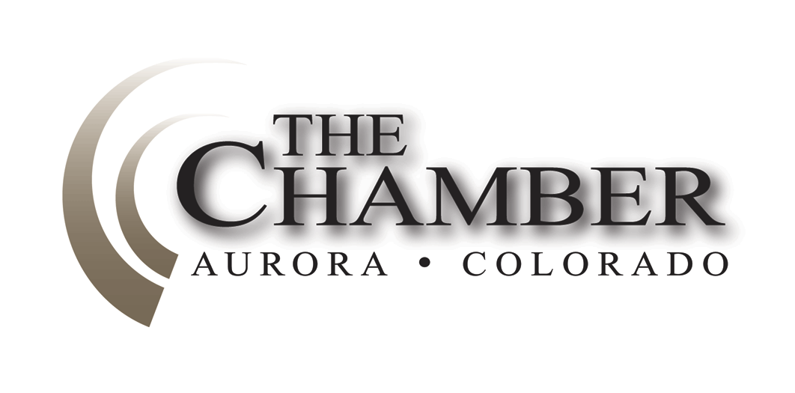Days until Sine Die: 23
April 15, 2014
http://www.coloradocapitolwatch.com/bill-tracker-votes/0/391/2014/0/
Axiom thanks the many news sources from which we gather relevant stories for our weekly newsletter. In most cases you will be able to read the full text article for each headline below by clicking on the link provided. The purpose of this format is to share newsworthy items while ensuring we adhere to copyright law.
Mike Kopp, Scott Gessler Make GOP Ballot in Governor’s Race
Denver Post
Former Sen. Mike Kopp and Secretary of State Scott Gessler made the ballot for governor during the Republican state assembly Saturday, knocking off three rivals who also wanted a chance to compete. Kopp received the most votes, at 34 percent, while Gessler received 33 percent. It was a stunning outcome considering that many bets prior to the convention had Gessler being the only candidate receiving the required 30 percent and knocking everyone else out. Sen. Greg Brophy received 19 percent, Adams County businessman Steve House 13 percent and LaSalle-area rancher Roni Bell Sylvester 2 percent. They are out of the race. Click here to read more.
Republican Tom Tancredo Makes the Ballot for Governor
Denver Post

Former Congressman Tom Tancredo has made the ballot for governor, according to the secretary of state's office. In order to petition onto the ballot, Tancredo's campaign had to collect 1,500 signatures from registered Republicans in each of the state's seven congressional districts. The petitions were due March 31. Tancredo on March 27 was the first governor's candidate to turn in his signatures. Click here to read more.

Senator Scott Renfroe, Weld County DA Ken Buck Make Ballot in 4th CD
Denver Post

State Sen. Scott Renfroe beat Weld County District Attorney Ken Buck for the top spot on the ballot in the race to succeed Congressman Cory Gardner, but both made the ballot Friday. Renfroe, who was called a "statesman" by several supporters, took 54 percent of the delegate vote while Buck won 46 percent at the 4th Congressional District assembly. Candidates need 30 percent of the vote to make the ballot. Weld County Commissioner Barbara Kirkmeyer also addressed the assembly but announced at the end that as she also was petitioning onto the ballot, the delegates who had committed to her were free to vote as they choose. Click here to read more.

Cynthia Coffman Big Winner in AG Contest, But Mark Waller Makes Ballot
Denver Post
Chief Deputy Attorney General Cynthia Coffman won a huge percentage of the GOP assembly vote Saturday, but not enough to knock off challenger state Representative Mark Waller. Coffman gained 69.3 percent of votes to Waller’s 30.7 percent. Click here to read more.
Hickenlooper Signs Several Bills
Office of the Governor
Governor Hickenlooper signed 10 bills into law last Monday. Among these were SB 58, which replaces the term “GED” with “high school equivalency examination” throughout state statute; and HB 1271, which extends a mental health provider’s duty to warn to include specific entities that, if purposefully damaged or attacked as a result of a mental health patient’s violent behavior, would jeopardize public health and safety. Also signed was HB 1142 which prohibits the Colorado Lottery Commission from allowing the sale of lottery tickets by any means other than in-person at a licensed lottery sales agent's physical place of business. The bill specifically bars the lottery commission from approving lottery sales through the Internet or other electronic devices.
New Chief of Technology Officer for State of Colorado
Office of Information Technology
Suma Nallapati recently joined the Governor’s Office of Information Technology (OIT) as the new Chief Technology Officer. Nallapati is an accomplished technology leader and consultant with more than seventeen years progressive experience in establishing and executing value driven global IT service strategy and delivery. She joins OIT from Catholic Health Initiatives, one of the nation’s largest healthcare networks. As Assistant Vice President, she led service delivery operations for a complex, multi-state, rapidly growing healthcare IT footprint.
Nallapati earned a master’s degree in nuclear physics and she also holds professional management and project management certifications. She is extremely passionate about fostering a culture of collaboration and achieving excellence within and across organizations. Nallapati started with OIT in late February. She will continue OIT’s important work of enhancing state IT systems for state agencies and the citizens of Colorado.
More Than $300 Million Pours in to Colorado Digital Startups in Q1
Denver Post

A new report shows that Colorado's digital startups were involved in fundraising or mergers-and-acquisitions deals totaling more than $300 million in the first quarter. Thirty-one Colorado tech startups secured $87.7 million in financing during the first three months of the year, according to Built In Colorado, an online startup hub chaired by Colorado Technology Association CEO Erik Mitisek. Another eight startups were acquired in deals valued at $225 million. The report also said 32 new startups were established during the quarter, down from 68 in the first quarter of 2013. Click here to read more.

Coal Production in Colorado Hits a 20-Year Low
Denver Post
Colorado coal production - hobbled by mine closures and a decline in demand for power-plant coal - hit a 20-year low in 2013. The state's nine mines produced 23.8 million tons of coal, according to the federal Energy Information Agency, a 17 percent decline from 2012 and down 41 percent from the 2004 peak. In 1993, the state produced 21.9 million tons. Click here to read more.

Aurora Wins Battle against Denver Hotels in Gaylord Hotel Project
Denver Post
A Denver District Court judge last Wednesday tossed out a lawsuit filed by a group of mostly Denver hotels against Aurora’s Gaylord Rockies Hotel and Conference Center, clearing the way for the 1,500 room hotel and water park near DIA. Judge Norman Haglund ruled that none of the claims by the plaintiffs to block the project had standing. In the lawsuit, the hotel group sought to overturn the $81.4 million award to Aurora under the Regional Tourism Act by the Colorado Economic Development Commission in 2012. Click here to read more.
Proposal to Hike Oil and Gas Fines by 1,400% Returns to Colorado Legislature
Denver Business Journal

A proposal to increase fines on the oil and gas industry is back before the state Legislature, but this year's version doesn't include the creation of a minimum daily fine for companies that violate Colorado regulations. And, unlike last year's bill, this one has the backing of the Colorado Oil & Gas Association, a big industry trade group in the state. Click here to read more.

Increase in Penalties for Oil & Gas Violations Passes Committee
Colorado House Democrats
The House Transportation & Energy Committee approved a bill last Tuesday to significantly increase penalties for oil and gas companies that violate Colorado law. The committee vote was 9-4 with Republican Rep. Don Coram (R-Montrose) joining the Democratic majority on the committee in voting for the bill. HB14-1356, sponsored by Rep. Mike Foote (D-Lafayette), allows for a maximum fine of $15,000 per violation per day. The current maximum fine is $1,000 per violation per day. The bill also removes the existing $10,000 cap for violations that do not result in significant adverse impacts to public health. The bill clarifies that companies will be penalized for every day a violation occurs.
The Colorado Oil and Gas Conservation Commission is required to hold a hearing if there is evidence that a company is responsible for gross negligence or willful misconduct and has the authority to prohibit new drilling permits or suspend current ones. COGCC must also publish a quarterly report online that lists violations and penalties that have been assessed.
Rep. Foote has been working on the bill over the past year with a broad group of stakeholders, including the oil and gas industry. The bill is supported by the Department of Natural Resources, which COGCC is a part of, the Colorado Oil and Gas Association, Conservation Colorado and other conservation groups across the state. The bill now heads to the House Finance Committee.
Telecom Reform Package Moves to Senate after House Approval
Denver Business Journal

A package of bills updating Colorado's outdated telecommunications regulation and funding the expansion of broadband services throughout the state passed received overwhelming approval last Tuesday. It will now move onto the Senate, which has stopped similar reform efforts from becoming law in the past. Click here to read more.

Student Success Act Passes House of Representatives
Colorado House Republicans
Last Friday, the Student Success Act passed the House of Representatives with broad bipartisan support. House Bill 14-1292, sponsored by Representatives Carole Murray (R-Castle Rock) and Millie Hamner (D-Dillon), will significantly increase school funding and improve the quality of education in Colorado. In addition to funds to buy down the negative factor, the Student Success Act improves financial transparency in school districts and provides more funding for charter school capital construction. The Student Success Act will now go to the Senate.
Senate Panel Passes Bill to Stop Phantom Foreclosure Charges
Denver Post

A bill that aims to stop lawyers from wrongly charging homeowners for nonexistent foreclosure lawsuits unanimously passed a state Senate committee last Tuesday. The bill, House Bill 14-1130, will go to the full Senate for approval before heading back to the House for consideration of Senate amendments. Click here to read more.

Committee OKs Change in Regional Tourism Act
Colorado House Democrats
The House Finance Committee approved a bill last week to modify the application process local governments must go through when applying for financing through Colorado’s Regional Tourism Act. The bill creates guardrails to protect taxpayer dollars. Local governments are able to apply for funds through the Regional Tourism Act to make improvements for local tourism projects. HB14-1350, sponsored by Speaker Mark Ferrandino (D-Denver), requires the Economic Development Commission to more closely follow the recommendation of a third-party economic analysis of the project. The bill will now be subject to approval by the House Appropriations committee prior to heading to the House floor.

Colorado Business Groups Bracing for Sick Leave Legislation
Denver Business Journal
Business leaders who haven’t gotten into as many legislative fights as they’d expected this session may have to oppose a measure they didn’t expect to see at the beginning of the year — one that would institute a paid-sick-leave program across the state. Click here to read more.

2014 Discover Colorado Rally at the Capitol
Colorado Tourism Office
To celebrate National Travel and Tourism Week and kick off the summer tourism season in Colorado, the Colorado Tourism Office has announced the 2014 Discover Colorado Rally!
Discover Colorado Rally
Tuesday, May 6, 2014
11am–1pm
Program kicks off at 11:30am
West Steps – State Capitol
Rally attendees will be able mingle with many of Colorado’s sports mascots, pet a gator from the Colorado Gators Reptile Park, enjoy local foods from the History Colorado Center and Haystack Mountain Cheese and partake in hands-on summer activities.
National Travel and Tourism Week is designed to create a greater appreciation of travel and tourism’s economic impact and the more than 10 million workers nationwide whose jobs depend on travel. If you are interested in promoting your destination or business at the rally contact Ilene at ikamsler@hotmail.com.

Boards and Commissions Appointment
Office of the Governor
Governor John Hickenlooper on Friday announced an appointment to the Oil and Gas Conservation Commission. The Colorado Oil and Gas Conservation Commission promotes the responsible development of Colorado’s oil and gas natural resources by balancing the efficient exploration and production of oil and gas resources, the prevention of waste and the protection of the public health, environment and mineral owners’ rights. This member is appointed for a term expiring July 1, 2015:
· James William Hawkins of Golden, to serve as a member with substantial experience in the oil and gas industry and with a college degree in petroleum geology or petroleum engineering, and as a Democrat, and occasioned by the resignation of Winston Perry Pearce of Denver.

The Calculator
House Bills Introduced: 376
Senate Bills Introduced: 192
Number of Bills PI’d: 133

“You can lead a man to Congress, but you can’t make him think.”
— Milton Berle

