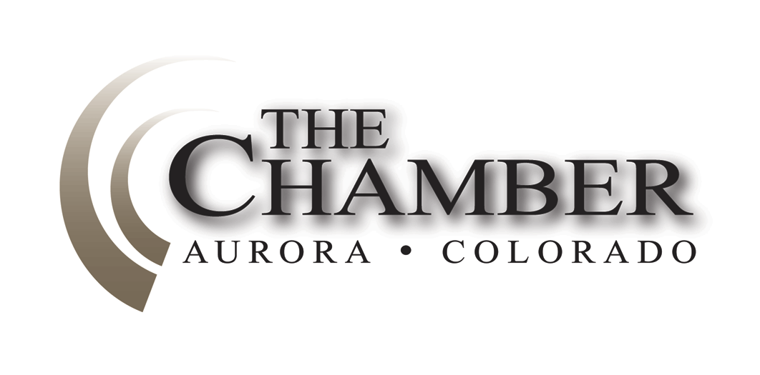
April 28, 2014
http://www.coloradocapitolwatch.com/bill-tracker-votes/0/391/2014/0/

“When you get into a tight place and everything goes against you, till it seems as though you could not hang on a minute longer, never give up then, for that is just the place and time that the tide will turn.”
- Harriet Beecher Stowe
Days until Sine Die: 9
Axiom thanks the many news sources from which we gather relevant stories for our weekly newsletter. In most cases you will be able to read the full text article for each headline below by clicking on the link provided. The purpose of this format is to share newsworthy items while ensuring we adhere to copyright law.
Construction-Defects Bill Close to Making Debut in Colorado Legislature
Denver Business Journal
Sen. Jessie Ulibarri said last week that he is close to introducing a bill to address the lack of condominiums being built in the Denver area. Metro-area mayors and business groups have worked for more than a year to change that law in a way that would make it harder to file class-action lawsuits for construction defects, saying that the current ease of legal action is largely responsible for just 2 percent of new residences being brought onto the market being multi-family dwellings for sale. Click here to read more.
Colorado HOAs Vow Strong Defense of Construction-Defects Law
Denver Post
Colorado homeowners associations plan a full-court press against any last-minute attempt to change the state's construction-defects law - if and when it comes. "We will make a whole lot of noise if that bill gets introduced. They are going to need to hear you roar," Community Associations Institute Colorado Legislative Action Committee chairwoman Molly Foley-Healy told a gathering of community managers last Tuesday in Denver. Click here to read more.
Bipartisan Incentive Bill Introduced
House Bill 14-1389 was introduced last week in hopes of keeping Colorado in the tech game. Intended to encourage the retention and growth of data centers in Colorado through the development of a sophisticated tax framework, the bill provides data center developers with additional incentive to invest in Colorado by allowing qualified new and refurbished data centers an exemption from the Colorado sales tax for information technology equipment purchased for the data center. Details on the exemption include:
· New facilities that are 25,000 square feet and greater and where an investment of $30M or more is made within a 60-month period; and
· Substantially refurbished buildings over 25,000 square feet that have been rebuilt or modified to accommodate a data center. A qualified refurbished facility must invest at least $15M within a 24 month period.
Qualification and approval will be determined by OEDIT and the Economic Development Commission. Exemptions are effective for purchases made after June 30, 2014.
Analysis of the Impact of Colorado’s Military Passes Unanimously
Colorado House Democrats
The House unanimously approved a bill Monday to create and present an analysis on the economic and strategic advantages of Colorado’s military operations to the Department of Defense. Beginning in 2015, the Department of Defense will begin to implement Base Realignment and Closure (BRAC) evaluations as it reduces its overall budget. SB14-157, sponsored by Rep. Su Ryden (D-Aurora), aims to demonstrate the importance of Colorado’s military bases and personnel to national security. Under the bill, the Department of Military and Veterans Affairs is required find a contractor to conduct the study and prepare its findings no later than April 15, 2015. The bill is now headed to Gov. John Hickenlooper’s desk.
Gov. Hickenlooper lauds passage of historic telecommunications reforms
Office of the Governor
Gov. John Hickenlooper today lauded a package of five telecommunications bills passed by both the House and the Senate. These bills will modernize the state’s telecommunications laws to provide regulatory certainty, expand broadband internet in unserved areas, and protect public safety.
The bills are:
• HB14-1330: An Update of Telecommunications Terminology for Intrastate Telecommunications Services
• HB14-1328: Deployment of Broadband into Unserved Areas of Colorado
• HB14-1329: Exemption of certain IP enabled services from oversight by the PUC
• HB14-1331: Reg of Basic Local Exchange Service as it Affects Effective Competition
• HB14-1327: Broadband Deployment Act
The governor called for telecommunications reform in his State of the State address at the beginning of the year, acknowledging that it was well past time to reform
our telecommunication laws. The bill package received bipartisan, statewide and regional support.
Colorado Bill to Increase Oil and Gas Fines Passes the House
Denver Business Journal
A proposal to hike Colorado's fines on oil and gas companies that violate the state's regulations last week passed the state's House of Representatives in a bipartisan, 40-22 vote. The bill, HB 1356, sponsored by Rep. Mike Foote, D-Lafayette, later passed through both the Senate Local Government and Appropriation committees and will now be heard on second reading on the Senate floor. Click here to read more.
Hickenlooper Will Convene Group to Review Colorado Severance Taxes
Denver Post
The Hickenlooper administration last Tuesday said it will form a stakeholder group to review the way oil and gas production is taxed in Colorado. The move - which is supported by some industry groups and lawmakers - comes after a legislative proposal to review severance taxes was filed the week before last. Click here to read more.
Workers' Comp Reform Bill Passes First Test, with Little Republican Support
Denver Business Journal
Big business and big labor held hands to promote a workers' compensation reform bill at the Colorado capitol last Tuesday, but it still wasn't enough to get most Republicans on board after its first hearing. Still, House Bill 14-1383, which expands from two to four the number of doctors that employers must let workers choose from for treatment of on-the-job injuries, moved on to the House floor after receiving 7-4 approval from the House Business, Labor, Economic and Workforce Development Committee. It passed on third reading in the House 37-27 with one excused. HB14-1383 will now be heard in the Senate. Click here to read more.
Increased Transparency Approved for Highway Private-Public Partnerships
Colorado Senate Majority Office
The Senate Transportation Committee last week approved a bipartisan effort to increase transparency and public participation for any future private-public partnerships for Colorado highway projects. Senate Bill 14-197 seeks to address well-publicized concerns that arose during the formation of the Colorado Department of Transportation’s High-Performance Transportation Enterprise contract for the Boulder Turnpike, which was finalized in February. That 50-year contract with Plenary Roads Denver established a private-public partnership for construction, maintenance, and tolling on U.S. Highway 36. The Colorado Department of Transportation testified in support of SB 14-197 and was consulted during the bill drafting process. In summary, SB 14-197 would do the following:
• Require public and legislative check-ins at critical points including town hall meetings.
• Require any agreement over 35 years to be approved by the legislature.
• Require local government involvement through steering committees.
• Require written notice to the legislature of any HOV changes.
• Expand annual legislative reporting requirements.
The Senate Transportation Committee approved SB 14-197 on a 4-1 bipartisan vote and the Senate Appropriations Committee approved it on a 6-1 vote. Next, the bill goes to the Senate floor for second reading consideration.
Lawmakers Want State Audit of U.S. 36 Deal
Denver Post
A group of state lawmakers are asking for a state audit of the controversial public-private deal reached to widen and collect tolls on U.S. 36 between Denver and Boulder. The request was made Tuesday by Rep. Mike Foote, a Lafayette Democrat, and 14 other state legislators in a letter to the Legislative Audit Committee and State Auditor Dianne Ray. Click here to read more.
House Passes Ferrandino’s Safeguards for Tourism Upgrades
Colorado House Democrats
The House passed a bill early last week to create guardrails in the application process for local governments that apply for financing through Colorado’s Regional Tourism Act. The final vote was 37-25. Currently local governments can apply for funding to upgrade and improve local tourism projects. HB14-1350, sponsored by Speaker Mark Ferrandino (D-Denver), requires third-party economic analyses of projects to more closely analyze the revenue that will be generated and directs the Economic Development Commission to adhere to the recommendation. After passing the House the bill headed to the Senate where it passed unamended through both the Finance and Appropriations committees and now awaits second reading on the Senate floor.
Proposal to Change Colorado Urban-Renewal Process Clears First Hurdle
Denver Business Journal
An effort to rein in what several people called the "abuses" of urban-renewal districts is moving ahead in the Colorado Legislature, having survived its first committee hearing despite warnings that it will bring many potential development projects to a screeching halt. House Minority Leader Brian DelGrosso, R-Loveland, said he has no intentions of ending or even slowing the increasingly common projects in which cities offer tax-increment financing to get retail or mixed-use developments into certain areas. But he believes his House Bill 1375 will send the signal that counties that have complained of being left out of a process that costs them some tax dollars need a seat at the table too. Click here to read more.
Urban Renewal Bill Passes Second and Third Reading in the House
HB 14-1375 passed on second reading in the House Friday evening, after an attempt to amend the bill to create a study failed on a 30-33 vote (with 2 excused). The bill sponsor, Rep. Brian DelGrosso, offered a number of clarifying technical amendments, most of which were adopted and are now part of the bill. Reps. Lebsock (D-Thornton), Foote (D-Lafayette) and Holbert (R-Parker) offered the amendment to delete the complicated, confusing and potentially ruinous section of the bill directing how urban renewal authorities finance projects; to instead require a study be performed together by the University of Colorado and Colorado State University. The study, which was narrowly defeated on a non-partisan vote, would determine once and for all the extent of the impacts of urban renewal projects on all taxing entities. The bill passed on third reading in the House this morning and now heads to the Senate.
Gardner, Udall in a Dead Heat in Senate Race, Quinnipiac Poll Finds
Denver Post
Colorado's U.S. Senate race between Republican Cory Gardner and Democrat Mark Udall is virtually tied, according to a new poll that shows the economy and health care are influencing voters. Sen. Udall is leading Congressman Gardner 45 percent to 44 percent, but the senator's approval ratings have dropped and fewer voters think he should be re-elected, a Quinnipiac University poll released early Thursday shows. Click here to read more.
The Calculator
House Bills Introduced: 396
Senate Bills Introduced: 214
Number of Bills PI’d: 146

