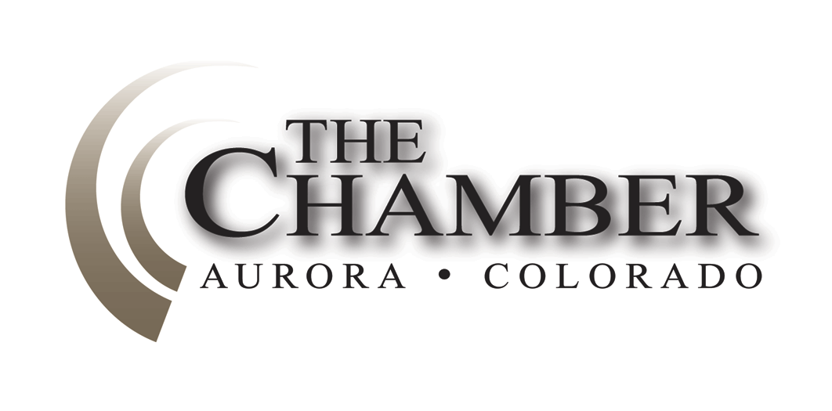“Things may come to those who wait, but only the things left by those who hustle.”
May 5, 2014
http://www.coloradocapitolwatch.com/bill-tracker-votes/0/391/2014/0/
— Abraham Lincoln
Days until Sine Die: 3
Axiom thanks the many news sources from which we gather relevant stories for our weekly newsletter. In most cases you will be able to read the full text article for each headline below by clicking on the link provided. The purpose of this format is to share newsworthy items while ensuring we adhere to copyright law.
Only Three Days Remaining in the 2014 Legislative Session
The second regular session of the sixty-eight General Assembly of the State of Colorado began at 10:00 am on January 8. As Colorado’s legislative session is limited to no more than 120 days, the legislature will adjourn sine die no later than midnight this Wednesday, May 7. Adjournment sine die (from the Latin “without day”) means “without assigning a day for further meeting or hearing.” Adjournment sine die for purposes of our state legislature is an adjournment until the next legislative session. Sine die are the two most beautiful words in the Latin language.
Gov. Hickenlooper Signs 2014-2015 Budget
Colorado House Democrats
Last Wednesday afternoon Gov. John Hickenlooper signed HB14-1336, otherwise known as the long bill or the state budget for fiscal year 2014-2015. The bill, which is sponsored by Rep. Crisanta Duran (D-Denver), chairwoman of the Joint Budget Committee, is the culmination of six months of budget negations over how to allocate state resources.
This year’s budget:
· Commits $144 million to recovery from the floods and wildfires of 2013
· Invests $44 million in wildfire prevention, including nearly $20 million for light-weight aircraft to assist with early wildfire detection
· Increases state funding for education by more than $400 per pupil and implements important reforms
· Boosts funding to our colleges and universities by $100 million
· Implements economic development programs to boost key industries, create good-paying jobs and build a strong, sustainable economy
· Increases funding for workforce development programs
· Increases provider rates for every provider in the state and gives a lift to Colorado’s hard-working public employees
· Increases the state reserve by more than $130 million, to 6.5 percent, to prepare for future emergencies and economic downturns
· Is balanced, as the state constitution requires, without raising taxes
Effort to Grant Colorado Communities More Local Control on Oil & Gas Dies
Denver Post
An effort to grant communities a measure of control over oil and gas operations has failed to produce an agreement this legislative session, meaning about a dozen November ballot initiatives that would give Colorado towns and counties far more power over drilling will likely proceed. A draft of the possible legislation specified that local governments may regulate noise, impose setbacks, conduct inspections or monitor oil and gas development to meet local permit conditions. No House Republicans had signed onto the possible legislation. Click here to read more.
Internet Gambling “Cybercafes” Face Uncertain Future
Denver Post
Lucky You 777, tucked away in a nondescript strip mall on Havana Street, does not look or sound much like a casino. Besides a bank of computer screens lit up with colorful sweepstakes games, there are no stern-looking pit bosses patrolling the floor, no cocktail waitresses serving drinks and, most noticeably, no noise. But Rep. Polly Lawrence, R-Roxborough Park, says businesses like these – often referred to as “Internet sweepstakes cafes” or “cybercafés” – are essentially illegal gambling operations that “feed on” hose lease able to afford it, such as seniors and low-income customers. Under Lawrence’s bill now moving through the state legislature, Lucky You 777 and any other establishment in Colorado equipped with “simulated gambling devices . . . .used to award prizes to customers” could find themselves out of luck – and out of business. Click here to read more.
HB 14-1392 passed on third reading in the House last Thursday, but has yet to be introduced in the Senate. The bill must be heard in the Senate on second reading by tomorrow in order to make it through the legislative process by sine die on Wednesday.
Data Center Incentive Bill Advances, then Hits Potential Snag
HB 14-1389, sponsored by Reps. Dan Pabon (D-Denver) and Brian DelGrosso (R-Loveland) and Sen. Mark Scheffel (R-Parker), passed on third reading in the House this morning, only to receive four committee assignments upon introduction in the Senate this afternoon. The bill, assigned to the Business, Labor & Technology, State, Veterans & Military Affairs, Finance, and Appropriations committees has a number of hurdles to clear prior to being heard on second reading in the Senate.
HB 1389 would provide a sales and use tax exemptions for the sale, storage and use of IT equipment used in a qualified data center or a qualified refurbished data center. It would also include IT equipment purchased to replace or upgrade IT equipment and IT equipment that is relocated to the state.
Historic Investment in K-12 Education
Colorado State Senate Majority Office
Last week, the Senate moved forward the Student Success Act (HB 14-1292), which invests an additional $180 million into K-12 education.
The Student Success Act begins to roll back budget cuts that occurred during the recession, and it ensures that taxpayers know exactly how the state is investing in K-12 education. In addition, the legislation makes strategic investments in a number of other programs. Here is how:
· Invests an additional $110 million to begin to roll back recession-era budget cuts
· Targets funding to one of our most vulnerable student populations with $20 million for struggling readers in grades K-3
· Builds on existing financial transparency to ensure parents, educators, and taxpayers are able to understand how K-12 funds are spent
· Provides capital construction funding for charter schools
HB 14-1292 had previously passed the House of Representatives on a 51 to 14 vote. It passed the Senate on a 33-2 vote.
Housing/Construction Defects Bill Gets Last-Minute Hearing
With only three days left in the legislative session, the long-awaited construction defects reform bill will finally get a hearing this afternoon. The bill is intended to address and minimize construction defects litigation which has essentially brought a halt to development and construction of owner-occupied condominiums in the state. SB 14-220, sponsored by Sen. Jessie Ulibarri (D-Commerce City), unfortunately faces virtually insurmountable odds , since it was assigned to two Senate committees (State Affairs and Judiciary) and is being heard in the first one this late in the session. The bill gives all owners in a homeowners’ association the opportunity to make informed choices about legal action by requiring 60 days notice to all owners prior to the start of any legal process. Notice must include an explanation of proposed litigation, including desired remedy; estimate of costs to association; and an estimate impact of legal action on home values and financing, including homes not involved in litigation. Finally, a majority vote of association members is required prior to commencing litigation.
Construction-Defects Reform Bill Companion Dies in Colorado Legislature
Denver Business Journal

A three-pronged approach to addressing the shortage of affordable condominiums in Colorado lost a prong Thursday when a Senate committee decided there was no need to have multiple state agencies study the issue. The Senate Appropriations Committee voted 5-2 to kill Senate Bill 219, which would have given the divisions of housing, insurance and law a combined $150,000 to collect data that would shine light on the reasons for the current shortage of owner-occupied affordable housing. Click here to read more.

Paid-Sick-Leave Bill Falls Victim to Opposition, Tight Legislative Budget
Denver Business Journal

A short-lived but controversial effort to launch a state-run, worker-funded paid-sick-leave program for all Colorado businesses is dead after its sponsor said there was not enough money in the 2014-15 budget to move it forward. Sen. Jessie Library, D-Commerce City, asked the Senate Appropriations Committee to kill his Senate Bill 196 on Thursday. He told the committee, however, that he hopes to begin work on the program again after the 2014 legislative session ends on May 7, hoping to find a solution that might bring large business groups and activist groups to the same table. Click here to read more.

Highway Project Transparency Bill Cruises Through Senate
Colorado Senate Majority Office
The Senate today gave bipartisan approval of the Transportation Enterprise Transparency Act, which increases disclosures, oversight and public input for private-public highway projects. The bill was passed on a 20-15 vote, and now goes to the House of Representatives with just seven legislative days remaining.
In summary, SB 14-197 would do the following:
· Require public and legislative check-ins at critical points including town hall meetings.
· Require any agreement over 35 years to be approved by the legislature.
· Require local government involvement through steering committees.
· Require written notice to the legislature of any HOV changes.
· Expand annual legislative reporting requirements.
Senate Group Shelves Front Range Drilling Study
Colorado Springs Gazette, Denver Business Journal
A divisive proposal to commission a new study about the health effects of drilling along Colorado's Front Range was defeated Tuesday. The Senate Appropriations Committee voted against the study amid concerns the Health Department already has the ability to study the effects. The measure had already passed in the House. Click here or here to read more.
Colorado Health Care Exchange Faces Financial Challenges
Denver Post
Connect for Health Colorado officials have touted the state’s insurance exchange as frugal and having relatively low fees. But after spending at least $100 million in federal funding, the exchange is scrambling to figure out how to sustain itself beyond this year. The exchange may find itself it a difficult position as it seeks solutions in coming months because some members of its own board, along with a vocal group of legislators, oppose fee increases. Its financial outlook may have worsened Friday when the state extended through 2015 health plans that aren’t compliant with the Affordable Care Act, which is likely to lower enrollments through the exchange. Click here to read more.
Harmful Amendment Fails, Gaylord Rockies Continues to Move Forward
Aurora Economic Development Council
Last week at the Colorado State Capitol witnessed efforts by some opposed to the Gaylord project to try and thwart the progress of the project. An amendment was offered to HB-1350 (Modifications to the Criteria for Regional Tourism Projects Approved by the Colorado Economic Development Commission through the "Colorado Regional Tourism Act") that would have negative consequences not only for the Gaylord project, but for all approved (and yet-to-be-approved) RTA projects. It would have greatly increased the chances of frivolous lawsuits against RTA projects to delay or prevent their successful implementation. Fortunately, the Aurora delegation including Senate President Morgan Carroll, Senator Nancy Todd and Senator Linda Newell immediately went to work with the bill sponsors and members of the Finance Committee to prevent the amendment from being introduced.
The Gaylord project will create thousands of construction jobs and 2,500 permanent jobs once the hotel and conference center are complete. Independent economists project that Gaylord will attract over 400,000 new visitors to the area contributing $273 million new dollars to Colorado's economy annually. The project is structured to ensure that developers are accountable and deliver on their promises before receiving any tax incentives. If you would like more detailed information on the project please visit: www.auroraedc.com.
Senate Approves Bill to Increase Maximum Penalty for Oil and Gas Violations
Colorado State Senate Majority Office
Last week, the State Senate approved legislation to increase Colorado’s oil and gas fines for the first time since 1955. The maximum daily fine would increase from the current $1,000 to $15,000 per rule violation. Under the bill, the Colorado Oil and Gas Conservation Commission may revoke permits or prohibit new ones in cases of gross negligence or willful misconduct. Also, fine information must be placed on the Commission’s website every quarter so that people can be more aware of issues in their communities. The Senate passed HB 14-1356 on a bipartisan 20-15 vote. After obtaining signatures from the Speaker of the House and Senate President, the bill will go to Gov. John Hickenlooper’s desk for his consideration
Bill Extending Effective Date of Definition of “Retail Sale” Heads to Governor
The Senate last week approved a bill to extend the effective date for the definition of “retail sale,” which was adopted last year with the passage of HB-1295, from July 1, 2014, until after the U.S. Congress enacts the proposed Federal “Marketplace Fairness Act” to authorize the states to require “certain retailers” to pay, collect, or remit state or local sales taxes. The bill, HB-1348, now goes to Governor John Hickenlooper for his signature. The measure was sponsored by Speaker Mark Ferrandino (D-Denver) and Senate Majority Leader Rollie Heath (D-Boulder).
Urban Renewal/TIF Reform Bill Moves to Senate
HB 14-1375, sponsored by Rep. Brian DelGrosso (R-Loveland) and Sen. Lois Tochtrop (D-Thornton) passed the House on third reading early last week and headed quickly to the Senate. The Senate Judiciary committee took up the bill on Wednesday afternoon but ran out of time to hear the numerous witnesses presented by both the proponents and opponents of the bill, when the committee was required to adjourn to join the rest of the Senate on the floor that evening. The chair of the Judiciary committee, Sen. Lucia Guzman (D-Denver) ultimately decided to lay the bill over until Monday, May 5, in order to continue testimony. This came as a bit of a surprise to everyone, with such little time left in the session, which must end by midnight on Wednesday, May 7.
Rep. Mark Waller, Citing Party Unity, Withdraws from Attorney General Race
Denver Post
A little more than two weeks after a disappointing showing in the Republican race to succeed John Suthers as Attorney General, Rep. Mark Waller withdrew from the contest on Monday. "Staying in wouldn't be the right thing to do moving forward," Waller, R-Colorado Springs, said. "The most important thing is keeping the seat in Republican hands." Click here to read more.
The Calculator
House Bills Introduced: 398
Senate Bills Introduced: 223
Number of Bills PI’d: 171

