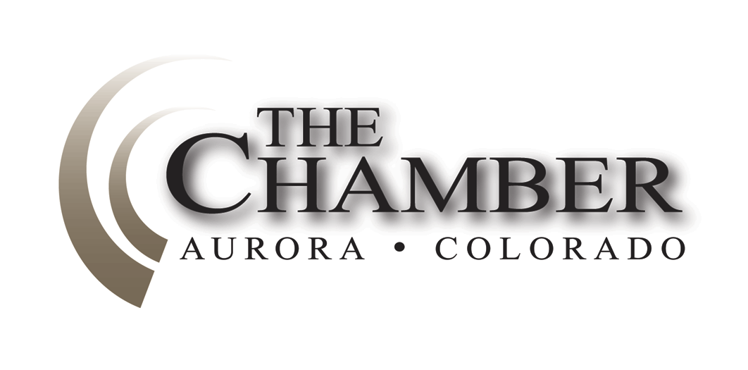
April 13, 2015

http://www.coloradocapitolwatch.com/bill-tracker-votes/0/391/2015/0/
"It is much more important to kill bad bills than to pass good ones." -Calvin Coolidge

Days Til Sine Die: 23
House approves state budget with most Republicans dissenting
The Denver Post
House lawmakers gave the $25 billion state budget bill final approval Thursday with two-thirds of the Republican caucus voting against the spending plan. The 45-20 vote sends the bill back to the Senate, which approved a different version a week ago. The House added 12 amendments and more than half included bipartisan support. The two chambers will meet next week to negotiate a compromise plan and the differences may prove tough to overcome. "No one got everything they want but together we passed a reasonable, responsible, balanced budget," said Rep. Millie Hamner, a Dillon Democrat and budget writer. The House vote represents a flip from the Senate, where the Republican majority supported it and most Democrats opposed it.
Colorado testing opt-out bill wins final Senate approval
The Denver Post
The state Senate on Tuesday gave final approval to a bill that would explicitly allow students to opt out of state assessments - the first piece of testing legislation to get through either chamber this year. Senate Bill 223 also would prohibit penalties against teachers, principals, districts, schools and students if opt-outs drive down test participation. The vote was 28-7. The bill was amended on the Senate floor to make clear that opting out is not to be encouraged. Under another amendment, the scores of tested students still could be used as a factor in measuring educator effectiveness, school performance plans and district accreditation.
The four other (non-testing) education bills that are on the move at the Capitol
Chalkbeat Colorado
While the focus primarily last week at the Capitol was on the budget and on testing, other education bills of interest are on the move. Here are the details. The Senate Tuesday gave 21-14 final approval to Senate Bill 15-216, which would affect the exclusive chartering authority of districts that are on the state's accountability watch list for more than three years. The bill would require that such districts lose that authority if they are in year three of priority improvement or turnaround and do not have an agreement with the State Charter School Institute governing placement of institute charters in the district. The goal of the bill, according to prime sponsor Sen. Owen Hill, R-Colorado Springs, is to give students in struggling districts more choices of high-quality schools. Under current law, the state can intervene in districts that have had low ratings for five consecutive years. Hill argues that students should have more choices after three years.
Hickenlooper signs Connect for Health Colorado audit bill
The Denver Business Journal
Connect for Health Colorado will be going under a more high-powered legislative microscope in the near future. Gov. John Hickenlooper on Friday signed into law Senate Bill 19, which allows the Office of the State Auditor to undertake a performance audit, rather than just a more cursory financial audit, on the state-chartered health insurance exchange. That will allow it to examine issues such as the exchange board's fee-setting methods and the organization's financial sustainability.
Colorado House votes to move tourism funds to film-incentive program
The Denver Business Journal
Colorado House of Representatives members on Wednesday re-inserted some - but not all - of the film-incentive funding that had been taken out of the state budget, though backers of the three-year-old incentive program still must convince key legislators to keep the money in the final budget bill.During a day-long budget debate, a bipartisan group of House members approved a deal that would cut tourism funding by $1 million and add that same amount to the film-incentive program. An overwhelming majority later approved moving $100,000 from the Office of Film, Television and Media to fund a study on how to help respite caregivers, leaving the program with a proposed $3.4 million for the fiscal year that begins on July 1.
Wine sellers and buyers benefit from pair of new Colorado laws
The Denver Business Journal
Gov. John Hickenlooper signed two more alcohol-related bills into law Wednesday - measures aimed at helping businesses and keeping people from over-consuming drinks. House Bill 1202, sponsored by Rep. Jonathan Singer, D-Longmont, allows businesses with liquor licenses that have been expired for less than six months to seek a simple re-issuance without having to restart the lengthy process of getting a new license. And HB 1244, sponsored by Singer and Rep. Dan Nordberg, R-Colorado Springs, allows club-goers to take partially consumed bottles of wine home with them after they are corked.
Colorado Senate passes bill reducing time to file defects claim
The Denver Post
The state Senate passed a bill Thursday that reduces the amount of time an owner of a single-family home gets to take legal action over faulty work done by a home builder, from six years to five years. Senate Bill 91 passed on a partisan 18-17 vote, with Republicans in the majority. It passed again on third reading Friday and now heads over to the Democrat-controlled House, where its fate is far less certain. The bill last month was stripped of its most controversial element, whereby multi-family homes along with single-family units would have been subject to a reduction in the "statute of repose" - the period during which a notice of claim of a defect can be filed.
Construction-defects bill gets green light in Colorado Senate
The Denver Post
The Colorado Senate on Friday gave preliminary approval to a bill that makes changes to Colorado's controversial construction-defects law - changes that proponents say will reinvigorate the moribund condominium construction market. The Senate passed the measure, Senate Bill 177, on a voice vote with Republicans in the majority. It is scheduled to face a third and final reading next week before heading to the House, where it faces significant opposition in the Democrat-controlled chamber. House Speaker Dickey Lee Hullinghorst, D-Boulder, declined to speak about the bill Friday but told reporters in January that she had serious reservations about it. Senate Republicans on Friday lauded the measure, which would make mediation or arbitration the preferred method of dispute resolution in construction-defects cases while barring homeowner associations from changing the project's declarations to open up the possibility of a lawsuit. It also would require that a majority of all homeowners in a condo or homeowners association approve legal action before it is taken.
Colorado's data-centers tax break still alive, student-loan repayment tax break dead
The Denver Business Journal
Even as Colorado legislators began the annual process of gutting and killing bills that don't fit into the state's budget, backers of a proposed tax break for data centers believe they may have found a way to reduce the scope of their proposal but still manage to get it passed. The House Appropriations Committee on Friday killed a proposal to offer tax breaks to employers who repaid some of their workers' student loans. And members voted to cut back significantly on a bill to establish a first-of-its-kind early-prediction system for floods and wildfires in this state. But the committee delayed House Bill 1158, which would offer a sales- and use-tax refund to companies that invest at least $20 million in opening or refurbishing a data center - an effort that economic developers have said is key to letting Colorado compete for the capital-heavy storage areas of major companies' cloud data.
Gov. Hickenlooper recognizes Child Abuse Prevention month, reminds Coloradans about statewide child abuse and neglect hotline
The Office of the Governor
On Tuesday, April 7, 2015Gov. John Hickenlooper joined Reggie Bicha, executive director of the Colorado Department of Human Services, lawmakers and child advocates today to recognize April as Child Abuse Prevention month, and to discuss Colorado's first statewide child abuse and neglect hotline - 1-844-CO-4-KIDS. Colorado's new child abuse and neglect hotline began operating on Jan. 1, 2015, and has already received 54,381 calls from concerned citizens, resulting in 8,196 screened-in reports of child abuse and neglect. The statewide hotline is the result of the governor's child welfare plan "Keeping Kids Safe and Families Healthy." The hotline serves as a direct, immediate and efficient route to Colorado's 64 counties and two tribal nations, which are responsible for accepting and responding to child abuse and neglect inquiries and reports. All callers speak with a call-taker 24 hours a day, 365 days a year.
"Children are undeniably Colorado's most precious resource," said Hickenlooper. "It is our responsibility to do everything we can to protect our children and ensure their safety."
"Everyone in our state plays a vital role in the prevention of child abuse and neglect, and we need to spread that message," said Bicha. "Thanks to the hotline, it's easier than ever to pick up the phone and make a call if you see something that concerns you. You dial the number, we'll make the call."
To learn more about the Colorado Child Abuse and Neglect Hotline and how to identify the signs of child abuse and neglect, go to CO4Kids.org.
Gov. Hickenlooper announces 11th Judicial District Nominating Commission appointment
The Office of the Governor
On Thursday, April 9, 2015 Gov. John Hickenlooper today announced an appointment to the 11th Judicial District Nominating Commission. There is a judicial district nominating commission for each of Colorado's 22 judicial districts that selects nominees for district and county judicial vacancies. Each district nominating commission is chaired by a justice of the Supreme Court, who is a non-voting member of the commission. Each judicial district nominating commission consists of seven citizens residing in that judicial district. No more than four members can be from the same political party, and there must be at least one voting member from each county in the district. In all districts with populations of more than 35,000, the voting members consist of three people admitted to practice law in Colorado and four people not admitted to practice law in Colorado. In judicial districts with populations under 35,000, at least four voting members are people not admitted to practice law in Colorado. It is determined by majority vote of the governor, attorney general and chief justice how many, if any, of the remaining three members will be persons admitted to practice law in Colorado. Commission members serve six-year terms. Non-lawyers, who are the majority of every nominating commission, are appointed by the governor. Lawyer members are appointed by joint action of the governor, attorney general, and chief justice. Effective immediately for a term expiring December 31, 2020:
• Jolene Lynn DeVries of Cotopaxi, to serve as an attorney and as a Republican from Fremont County, appointed.

The Calculator
House Bills Introduced: 350
Senate Bills Introduced: 265
Number of Bills PI'd: 161
Bills Signed by the Governor: 113

