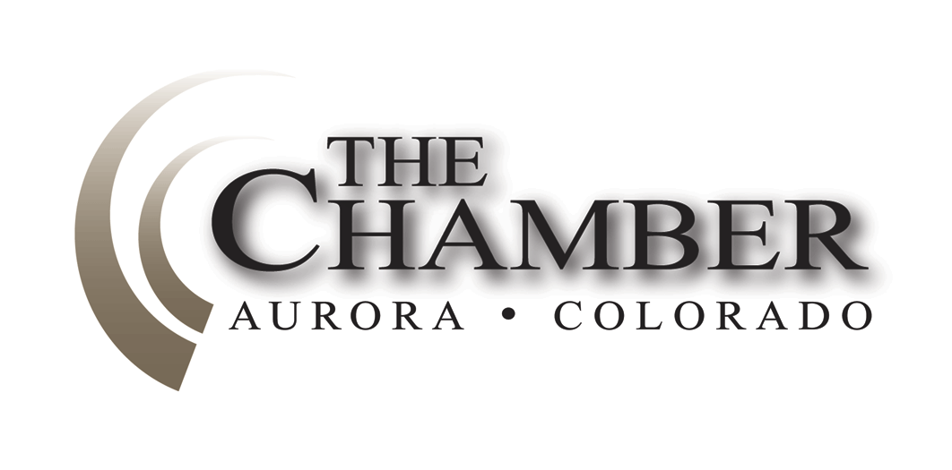
May 4, 2015

http://www.coloradocapitolwatch.com/bill-tracker-votes/0/391/2015/0/
"Democracy is the worst form of government, except for all the others."
- Winston Churchill

Days Til Sine Die: 3
With only three days remaining in the 2015 legislative session the fate of a large number of bills, some quite controversial, remains to be determined. Watch your email at the end of this week for End of Session reports prepared specifically for you by your Axiom team.
Colorado's construction-defects bill dies in committee
The Denver Post
Affordable-housing advocates and metro-area mayors made a last-minute plea to state lawmakers Monday to give a bill that would revamp Colorado's construction defects statute a "fair hearing" in the House. But the House State, Veterans and Military Affairs Committee, considered a "kill committee" for the measure, snuffed the life out of Senate Bill 177 last Monday night after nearly six hours of testimony. The vote, along partisan lines, was 6-5 in the Democrat-controlled committee. Rep. Joe Salazar, vice-chair of the committee and a Democrat, told bill sponsors "you would have had me" if they could have convinced him of the bill's positive effect on affordable housing.
House Republicans to kill business-opposed bills
Denver Business Journal
Two weeks ago, GOP state Rep. Paul Lundeen charged into a National Federation of Independent Business gathering at the Capitol and declared, following a long House Judiciary Committee hearing the previous night on a bill expanding worker access to employee personnel files, that self-described moderate Democrats were not voting with the business community. It turns out that they were just sitting on another committee and waiting until the end of the session to wield their influence.

Rejected for years, felony DUI bill moves closer to approval
The Denver Post
A years-long push at the statehouse to make repeated drunk driving a felony charge moved a step closer to final approval after receiving support from a state Senate panel last week. The felony DUI bill -introduced each year since at least 2010 - is advancing with bipartisan support and the backing of Gov. John Hickenlooper, who made it one of his administration's top priorities this session. "This is a serious problem and takes lives nearly every day on the highways and roadways in Colorado," said Dave Hall, a lobbyist for the Colorado State Patrol, testifying on behalf of the Hickenlooper administration.
Colorado health insurance exchange eyes potential fee increases
The Denver Post
Connect for Health Colorado board members are considering hiking fees the exchange charges on individual health plans to raise more revenue in 2016. "Clearly our fees are too low," board member and finance and operations committee chair Arnold Salazar said Tuesday during a meeting of the committee. With user fees of 1.4 percent on health insurance plans adjusted upward, perhaps as high as 3.5 percent to 4.5 percent, Salazar said, it's a different forecast. "We are well within striking distance of sustainability," Salazar said. "We want to make sure we have the revenue to make this sustainable."
Urban renewal at heart of dueling bills in Colorado Statehouse
The Gazette
Colorado counties are again trying to get a say in how and when property tax dollars are pledged to urban renewal projects. Gov. John Hickenlooper vetoed a bill in 2014 that attempted to do just that, but state lawmakers are trying again this year. In an interesting twist, however, counties are lobbying for a version of the bill in the Democrat-controlled House, and cities are lobbying for a similar law the GOP-held Senate. Competing bills that address the same issue have been a common theme during this session with a divided Legislature.
Colorado Senate set to vote on controversial bill that could stymie Aurora hotel project
The Gazette
The burning question in the Colorado Legislature is whether a proposed bill would affect millions of dollars in tax increment financing incentives pledged to the controversial Gaylord Rockies hotel and conference center in Aurora. The answer at the Capitol on Wednesday night after a marathon hearing on Senate Bill 284 was an unequivocal "maybe." SB 284 would require voter approval when tax incentives intended for urban redevelopment projects are instead pledged to developments on agricultural land. The bill, which cleared committee with a 4-1 vote late Wednesday, and is still awaiting 2nd reading in the Senate.
Colorado Lawmakers Struggle with Dueling Telecom Oversight Bills
Government Technology
House Democrats and Senate Republicans are at odds again, this time over whether to renew all or just part of the Office of Consumer Counsel, a state agency that represents the public during hearings for proposed utility rate increases. Senate Republicans want to continue the Office of Consumer Counsel without its oversight function for the telecom industry. Sen. Jerry Sonnenberg, R-Sterling, said that deregulation of the telecom industry last year, coupled with significant technology changes that have ended monopolies in the industry, make regulation unnecessary. Democrats in the House want the office to be reauthorized to maintain the telecom oversight role. Advocates say oversight is needed over 911 fees on telephone bills and that deregulation included a clawback provision necessitating the office to analyze whether the industry is handling its new freedoms.
Cybercafes going away? Law causes 1 local business to close
The Pueblo Chieftain
The future of the state's sweepstakes cybercafes seems bleak after passage of Colorado House Bill 1047. This bill, signed by Gov. John Hickenlooper on March 13, declares that cafes and similar establishments that utilize simulated gambling devices to award prizes are illegal. In broad terms, a simulated gambling device is defined as "a mechanically or electronically operated machine, network, system, program or device that is used by an entrant and that displays simulated gambling displays on a screen or other mechanism."
Personal property tax cut, tax-haven measure among business bills that died Friday in Legislature
Denver Business Journal
The waning days of any legislative session leave the halls of the Colorado Capitol littered with the corpses of business bills and other bills cut down in committees or floor votes - and this year is no exception.
Bills on subjects ranging from tax breaks to road funding fell by the wayside Friday as the Senate and House met in day-long sessions to try to take care of legislation that must be voted up or down by the Legislature adjourns on Wednesday.
Legislation of Interest
House Bill 15-1367 Concerning Retail Marijuana Taxes
Senate Bill 15-287 Concerning the restoration for Presidential Primary in Colorado
Buckner Taking Medical Leave for Rest of Session
Press Release from House Democrats
On April 28, 2015 Rep. John Buckner announced today that he will be taking leave for the remainder of the 2015 legislative session, which ends on May 6, to proactively address health concerns. Rep. Buckner, D-Aurora, sent the following statement to Speaker Dickey Lee Hullinghorst, who read it to the chamber this morning:
"I am sure by now many of you have noticed that I have been absent from the legislature this past week. While I am sure some of you are relieved to get a break from me, don't think for a moment that you've run me off!" "I want everyone to know that I am doing well, however, at the recommendation of my physician, I'll need to extend my leave from the legislature through the end of the session. As much as it disappoints me not to be there to represent House District 40, this time away is helping to keep me from taking a step backwards."
Rep. Buckner is chairman of the House Education Committee, where he has been instrumental in streamlining assessments in Colorado public schools and helping rural school districts devote more time to education in their classrooms. In his absence, Rep. Brittany Pettersen, D-Lakewood, will act as chairwoman of the Education Committee. Speaker Hullinghorst appointed Rep. Millie Hamner, D-Dillon, to the Education Committee and Rep. KC Becker, D-Boulder, to Rep. Buckner's other committee seat, Judiciary, for the remainder of the session.
Gov. Hickenlooper announces Boards and Commissions appointments
Office of The Governor
On Tuesday, April 28, 2015 Gov. John Hickenlooper announced several Boards and Commissions appointments. The appointments were to the Advisory Committee on Governmental Accounting, and the Collection Agency Board.
The Advisory Committee on Governmental Accounting assists the auditor in formulating and prescribing a classification of accounts which will be uniform for every level of local government with exceptions (population, etc). Effective May 18, 2015 for terms expiring May 18, 2019:
• Kevin F. Collins of Franktown, to serve as a representative of special services districts, reappointed;
• Patricia Jeanne Soderberg of Thornton, to serve as a representative of city and county government, appointed;
• James Edward Rae of Windsor, to serve as a certified public accountant, appointed.
The Collection Agency Board makes recommendations on the licensing of collection agencies and investigates complaints against them. For terms expiring April 30, 2018:
• Sandra Lee Lopez of Littleton, to serve as a member of the public, appointed;
• Robert L. LaMarr of Loveland, to serve as a representative of the collection business, reappointed.
Gov. Hickenlooper names Irv Halter as Executive Director of Department of Local Affairs
Office of The Governor
On Tuesday, April 28, 2015 Gov. John Hickenlooper announced Irving "Irv" Halter, Jr., will be the executive director of the Department of Local Affairs (DOLA) effective May 1, 2015. "Irv Halter has a distinguished career in the public and private sector. His vast experience and passion for good government will greatly benefit the State of Colorado," said Hickenlooper. "We are thrilled he will be leading the agency and joining our team." Halter, a retired major general in the U.S. Air Force, joins the state after a distinguished military career with more than 32 years as an Air Force Officer. Halter served as a fighter pilot in the Air Force, leading more than 35,000 airmen and managing assets valued in the billions. As vice director of operations, Halter also advised the Chairman of the Joint Chiefs of Staff in his duties as principal military advisor to the Secretary of Defense and the President.
The Calculator
House Bills Introduced: 392
Senate Bills Introduced: 289
Number of Bills PI'd: 258
Bills Signed by the Governor: 173

