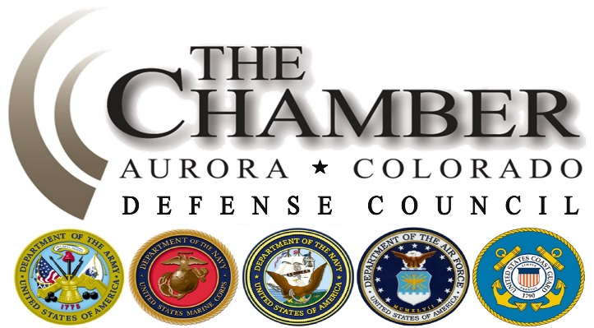

Our Mission:
To promote and support the people and missions of the U.S. military by working with the local military installations, the aerospace and defense industries and other business representatives.

Our Goals:
- Take care of the troops, veterans and their families
- Educate and develop business to expand the economic impact of the aerospace and defense industries
- Improve collaboration between civilian and military communities
- Develop a stronger community knowledge and awareness of the Defense Council, aerospace and defense industries and military contributions in the Metro area

